**Data Collection and Preprocessing Phase**

|  |  |
| --- | --- |
| Date | 10 July 2024 |
| Team ID | Team-739867 |
| Project Title | SmartLender – Envisioning Success:  Predicting University Scores With Machine Learning |
| Maximum Marks | 6 Marks |

**Data Exploration and Preprocessing Report**

Dataset variables will be statistically analyzed to identify patterns and outliers, with Python employed for preprocessing tasks like normalization and feature engineering. Data cleaning will address missing values and outliers, ensuring quality for subsequent analysis and modeling, and forming a strong foundation for insights and predictions.

|  |  |
| --- | --- |
| **Section** | **Description** |
| Data Overview |  |

|  |  |
| --- | --- |
| Univariate Analysis |  |

|  |  |
| --- | --- |
| **B**ivariate Analysis |  |



Multivariate Analysis



**Data Preprocessing Cod**



**e Screenshots**



Loading Data

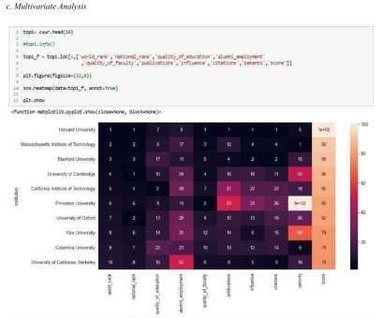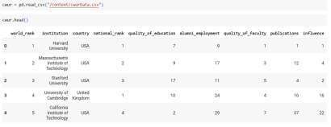

|  |  |
| --- | --- |
| Handling Null Values |  |
| Viewing outliers |  |

|  |  |
| --- | --- |
|  |  |
| Handling outliers |  |

|  |  |
| --- | --- |
|  |  |
| Saved Processed Data |  |